2023 NFDA Int’l Convention & Expo
Las Vegas, Nevada

Policy: Affiliate & Exhibitor Functions Involving Convention Attendees
Affiliates and exhibitors are not permitted to hold any function which involves convention attendees, including, but not limited to meetings, seminars, food & beverage events, receptions, facility tours/open houses, etc. during the following days/times when official NFDA convention functions are occurring:

Fri, Sep 8th 8am – 8pm
Sat, Sep 9th 8am – 4pm
Sun, Sep 10th 8am – 4pm
Mon, Sep 11th 12pm – 5pm
Tues, Sep 12th 12pm – 5pm
Wed, Sep 13th 9am – 12pm
Thurs, Sep 14th 8am – 12pm

There are no restrictions as to when affiliates and exhibitors may hold a function that does not include convention attendees, ie: business meeting involving organizational staff, sales staff, etc.

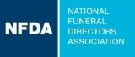
2023 NFDA
International Convention & Expo
Las Vegas, NV
September 10th-13th
Affiliate/Exhibitor Meeting Space Request

Dear Colleague,

The NFDA Meetings Department is ready to help you secure meeting space in Las Vegas,NV.

If you require meeting space at the Las Vegas Convention Center Monday, September 11th, 2023 – Wednesday, September 13th, 2023, review the document Policy: Affiliate & Exhibitor Functions Involving Convention Attendees for guidelines. Email any questions or complete and email the document Affiliate/Exhibitor Meeting Space Request Form to me at kklemens@nfda.org. Meeting space is assigned on a first come, first served basis, and is based upon NFDA approval.

Limited complimentary meeting space is available. After that the Las Vegas Convention Center may offer space with a rental cost. You are responsible for all charges related to your meeting.

Email confirmation will be sent to the contact noted on the Meeting Space Request Form within two weeks of receipt by NFDA. All approved requests will be forwarded to the Las Vegas Convention Center, at which time they will contact you to begin planning your event and establish payment.

Thank you for your support and see you in Baltimore.

Kristi Klemens

Director Convention, Meetings and Events

NFDA

13625 Bishop’s Drive

Brookfield, WI 53005

KKlemens@nfda.org

www.nfda.org

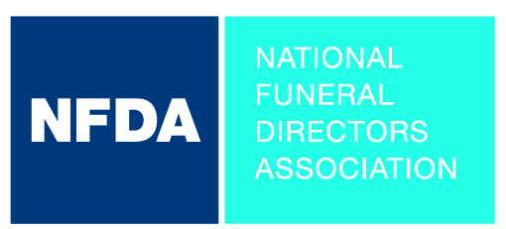
2023 NFDA International Convention & Expo, Las Vegas, NV
Affiliate/Exhibitor Meeting Space Request Form

Meeting space is assigned on a first come, first served basis.
Contact Name |  |  |  |  |  |  |  |  |  | Title
Company Name
Mailing Address
Phone |  |  |  |  |  |  |  |  |  | Fax
Email
Event Name
Event Day/Date | Monday, Sep 11th |  |  | Tuesday, Sep 12th |  |  |  | Wednesday, Sep 13th |  |  |  | Other
Event Start/
End Time
Type of Event | Business Mtg.  Reception |  |  |  |  | Other:
Speaker/Topic | Name: |  |  |  |  |  |  | Topic:
On-site Contact | Name: |  |  |  |  |  |  |  |  | Cell #
On-site Contact | Arrival Date: |  |  | Arrival Time: |  |  |  | Departure Date: |  |  |  |  | Departure Time:
Room Set Up:  Check set-up types | Conference:  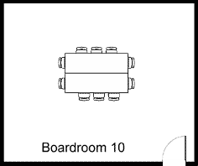 |  | Hollow Sq.  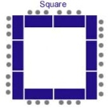 |  | U-Shape  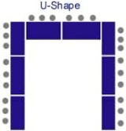 |  |  | Classroom  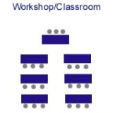 |  | Theatre  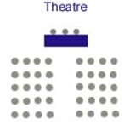 |  |  | Rounds  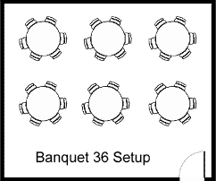 | Reception  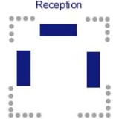
Room Set Up:  Check set-up types | Stage  Yes  No |  | Stage Size |  | Podium  Table Top  None  Standing |  |  |  |  | Other
Estimated #  of Attendees |  |  |  | Who are the attendees?
Meeting  Requirements  All that apply | Audio Visual Internet Food & Beverage |  |  |  |  |  |  |  | Other
Special
Instructions

Email this form to the NFDA Meetings Department: Kristi Klemens, kklemens@nfda.org

Meeting Related Charges:
All charges are the responsibility of the requesting company or organization including, but not limited to, room rental, room set changes, food and beverage, delivery, set-up, audio visual, internet, electric services, and other meeting related charges.

Please sign to acknowledge that you have read and understand the above statement.

Signature |  | Date:
For Administrative Use:
NFDA Approved Denied Date
Name Signature
Comments

